FEELING DEPRESSED?

A clinical research study for an investigational
medication is currently enrolling people who

- Are currently taking an antidepressant but still need
additional relief
OR
- Are not taking any antidepressant medications but
think they may have depression

Minimum Qualifications

- An adult between 18 and 65 years old
- Currently experiencing symptoms of depression

What is Involved?
- Receive study medication and study-related
Medical care at no cost

COMPENSATION FOR TIME AND TRAVEL MAY ALSO BE PROVIDED

To learn more and find out if you may qualify, call
Rhode Island Mood & Memory Research Institute at
401-435-8950 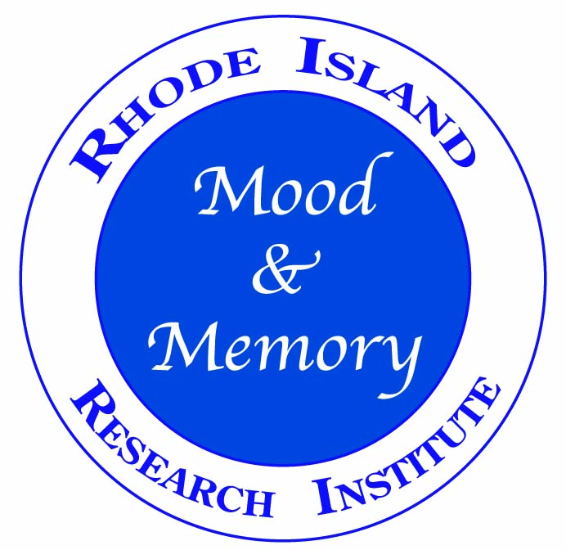
www.rimmri.com

